# Client and Topic

My final website project will be a website for my department at work. I work in the learning/training department at work. We are having issues tracking how many hours associates have spent in a newly trained path. We have a policy requiring them to do eighty hours in any new trained path. The main problem is leaders in the operation want to know how many associates are working on getting to eighty hours. However, this would take hours and team hours to find out. Making a website that could help track this would help a lot.

# Development Process and Engagement

I am creating this website for everyone at my job including me. During development, I will be showing the progress to my peers and others who will use it to get feedback. I will then use this feedback to improve the update the website till it is easy to use for everyone.

# Testing

Before launching the website, I will test the website by having my co-workers test it and others at work. My main testing phase will be using the website for a week at work. During and afterwards getting feedback from everyone and then making adjustments as needed. This testing will also test the website on different web browsers and monitor sizes. At my work, many people use different web browsers and different monitor sizes. Creating the best layout for each experience will be important.

# Description

The goal of this website for the business will be to mainly track how associates are in the process of reaching eighty hours in a new trained path as well as which path they are in and how many total. The intended audience is made of mainly twenty to forty years old, comprised of all genders and races. They we all be located in Florida. Large range of different ethnicities. Economically most will be in the lower or middle class. Education is mainly high school some college level. They access the information on laptops some use different web browsers and some use monitors others do not. With the audience using different web browsers and monitor sizes I will need to make sure the website will function and look good across the board. My website will be unique as this information will not be able to be found anywhere else. I will need to get some photos from other sources to put on the site. Content will be updated as users enter data into the forum so at least daily there will be changes.

# Growth and Maintenance

The website will grow naturally over time as more users enter data the data inside of it will grow. It may even evolve one day to not just being used at my location but across the country and maybe even the world. One thing I may have to add as it grows is additional details and more data points. Maintaining the website could be done by going through the forum data and verifying it’s accurate. This task will be done on an as-needed basis maybe a good estimate is once a month.

# Organization

The website will be organized in a hybrid structure. Home page, 5 different HTML sites that split from that but can connect back to it via the menu bar. 1 of those html sites will branch off into 3 more html sites. Also, at the bottom of every site will be a link to the privacy page. Sub-topics include search engines to find things on the site. How this works explains how to site operates. AAs in policy this is the page that will show how many associates are in the eighty-hour policy and what path. 80 Policy is where you can find a copy of the 80-hour policy for reference. Login pages This is where allowed users can log in. After that, they can either go to Add AAs, Remove AAs, or Full data. Add AAs is the forum to add AAs that are in training. Remove AAs is where they can go to remove them once they are done. Full data shows what data is on record currently.

I have included the diagram of the website below.

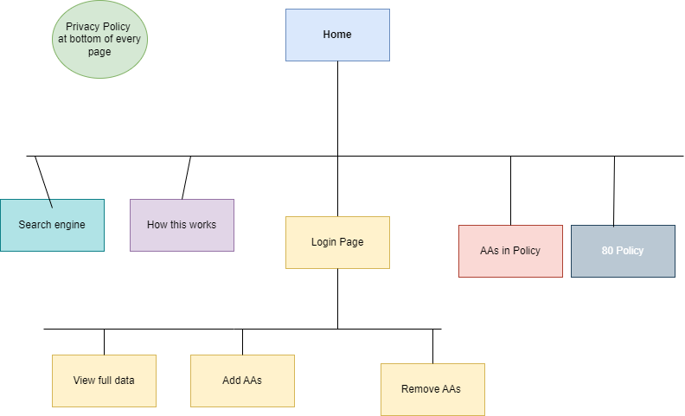

Home page wireframe:

Interior page #1 wireframe:

# Web Hosting

I will be looking for reliable uptime, secure sockets layer, 24-7 security monitoring, and at least 25 GB. Having reliable uptime will be important as the company runs 24-7. That leads to having the security monitoring also being 24-7. Having the secure sockets layer is important to ensure the data is protected. The 25 GB of memory is key because it needs to have a large enough memory to store the information from the forum. The programming languages required will be HTML, CSS, JavaScript, and Favicon. The domain name will be associatesin80hours.com. The name is rememberable which is why I choose it. Also, it will make it easy for users to start typing in their web browsers to find the site.

# Marketing

The website will be marketed by talking to the teams at work during our daily meetings and of course, the word will spread during the week’s test phase as well. I can optimize the search engine by making sure to include keywords and mag-tags. Also, I will need to make sure each page is unique and different from other sites used already for other tasks. As well as ensure good heading to help with formatting and navigation of the site.

# Security

This website will not have an e-commerce component. The website will be protected by a login and password. This will be required to enter new forum data or changes. Users will be created, and new accounts will not be able to be created without admin action. Data will be able to be viewed with no login or account required. To help keep the data secure as far as personal data no one will be able to see the info of a person without logging in. The only data able to view without login is the overall number of how many associates in each path but you will not be able to see who those associates are.